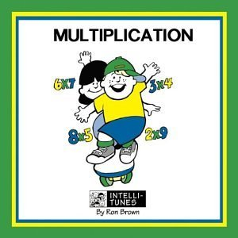
Multiplication Madness on Wednesdays!
The following is how the students will be quizzed. Remember, they are allowed to retake ANY quiz they want for a better grade. All quizzes will be averaged for a multiplication test grade each quarter.

xO-1
x2
x3
x0-3 mixed,
x4
x5
x6
x4-6 mixed
x7
x8
x9
x7-9 mixed
x10
x11
x12
x0-12mixed

After all facts are completed, a mixed x0-12 quiz will be given each Wednesday.
All quizzes are 50 problems. They will get 5 minutes to complete all 50.
The first quiz will be on Wednesday, October 18^{th.}! (x0-1)
They will continue each Wednesday after that!

